Experiment 28
You cloned a repository earlier, and now another collaborator has
made changes to it. You need to pull the latest changes from GitHub
to keep your local copy up to date.
Tasks:
• Clone a repository (from previous questions).
• Ask a collaborator to make a change and push it to the GitHub
repository.
• Use git pull origin main to pull the latest changes.
• Verify that the changes made by your collaborator appear in
your local repository.
Step 1: Open your GitHub repository
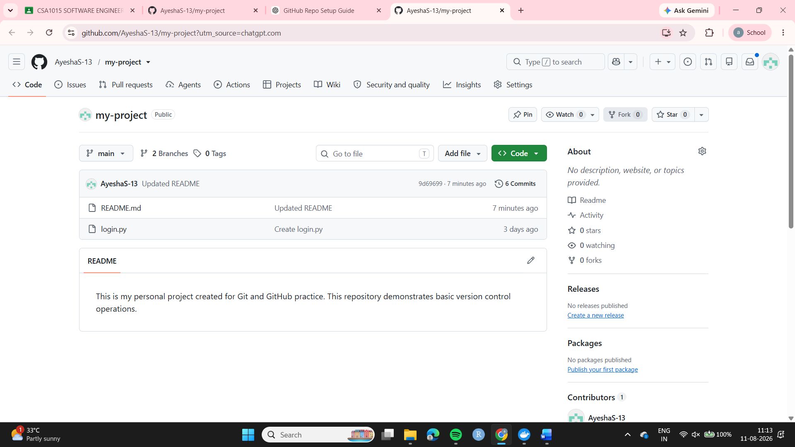
Step 2: Make a collaborator change on GitHub README.md
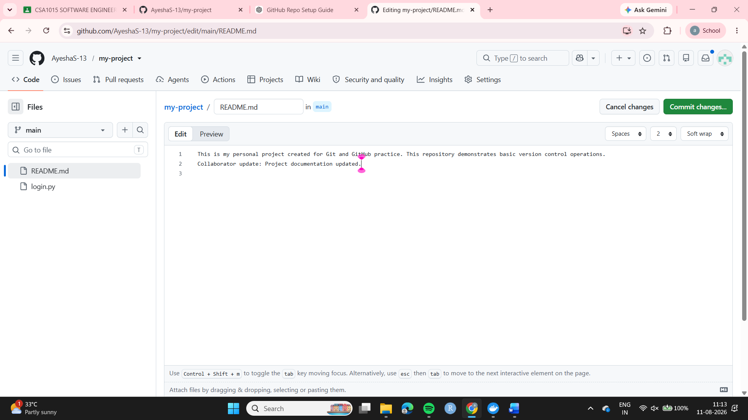
Open Git Bash.
Run: cd ~/OneDrive/Documents/Desktop/my-project-clone
Then check your status: git status
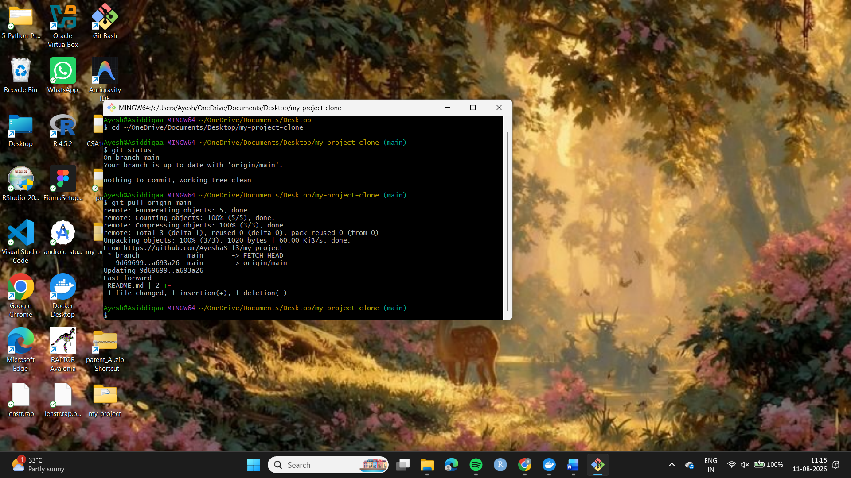
Step 4: Pull the collaborator's changes. Step 5: Verify the change cat README.md
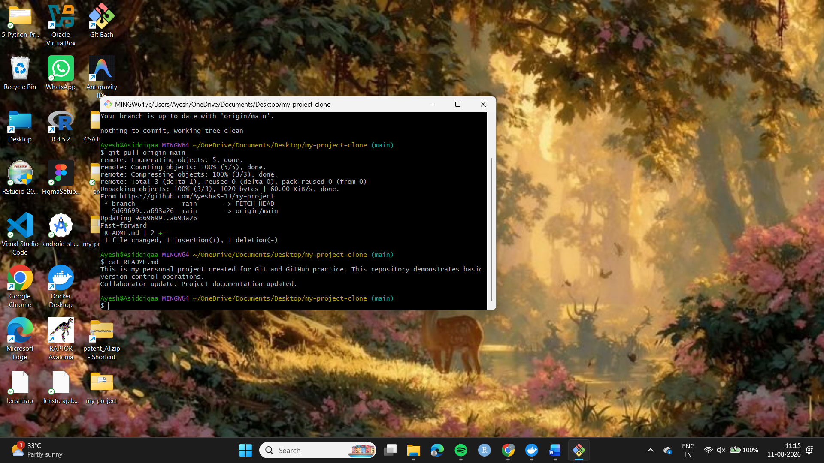
Result
The latest changes made by the collaborator on GitHub were successfully retrieved using git pull origin main. The updated README.md file was verified in the local repository.

